**MM 442/642 – Quality Assurance In Metallurgy**

**Group Project -1**

**Seat Lightweighting Project**



**Course Coordinator: Prof. Hemant Borkar**

**GROUP- 9**

**Mohammad Zaeem Bichu (200005022)**

**Sejal Kotian (200005042)**

**Shreya Singh (200005044)**

**Tatiya Vimalkumar Pramod (200005048)**

**Introduction:** The significance of the given challenge of automobile seat weight reduction can be seen from the above chart. Interiors comprise a considerable (~ 10-15 %) weight portion of the concerned automobile. To proceed with the solution, we propose that the changes discussed in the following section be made to the design.

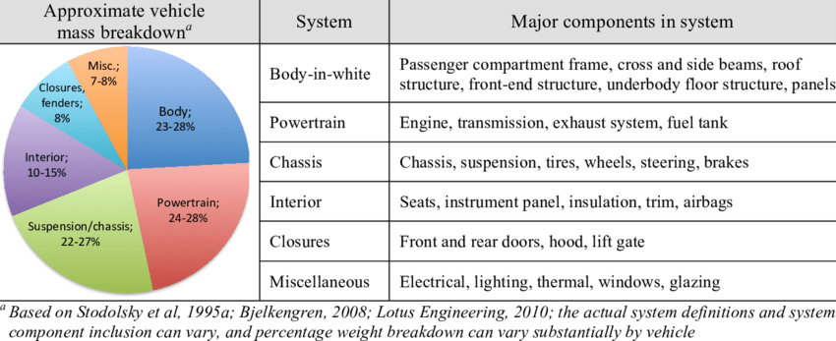

**Objective:** To emphasize the importance of reducing car seat weight as part of a Six Sigma quality project

**Key strategies within the Six Sigma framework :**

* Advanced materials selection (e.g., lightweight alloys, composites)
* Optimization of structural design and component integration
* Simulation and modeling for performance evaluation
* Collaboration with suppliers and partners for innovative solutions

**Overview:** We have considered replacing the materials used for the following components with the given materials

| **Component** | **Existing Material** | **Replacement Material** |
| --- | --- | --- |
| Slider Assembly | Mild Steel | SiC-reinforced aluminum matrix composite |
| Handrest Foam | PU Foam | 2/3rd soft PU foam combined with 1/3rd hard PU foam. |

**Slider Assembly:**

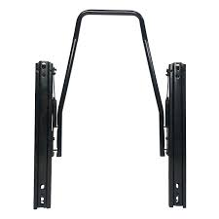

Slider Assembly

The slider assembly within car seats is a crucial component that demands specific mechanical properties to ensure its functionality, durability, and safety. Here's a rundown of the essential mechanical traits necessary for an effective slider assembly:

**Strength**: It's imperative for the slider assembly to boast robust strength capable of supporting the weight of occupants and enduring the dynamic loads experienced during vehicle operation.

**Stiffness**: Maintaining sufficient stiffness is key to upholding stability and preventing excessive deflection or deformation, especially under heavy loads.

**Wear Resistance**: Components like rails and bearings must exhibit high wear resistance to withstand the rigors of frequent movement, ensuring long-lasting reliability.

**Friction Coefficient**: Smooth and controlled sliding motion of the seat hinges on achieving the proper friction characteristics, striking a balance between easy adjustment and adequate resistance to unintended movement.

**Corrosion Resistance**: Given exposure to various environmental elements like moisture, temperature variations, and road salt, corrosion resistance is vital to the longevity of the slider assembly.

**Fatigue Resistance**: Designing components capable of withstanding repeated loading cycles without succumbing to fatigue failure is essential for ensuring long-term durability and safety.

**Dimensional Stability**: The slider assembly must maintain dimensional stability across different operating conditions to prevent fitment issues and deliver consistent performance over time.

**Ease of Assembly**: Emphasizing ease of assembly streamlines manufacturing processes, ensuring efficiency without compromising quality or reliability.

**Weight**: While not a mechanical property in itself, minimizing the weight of the slider assembly contributes to broader vehicle weight reduction efforts, enhancing overall performance and safety.

After thorough research and analysis of various materials, including Al6061 and SiC-reinforced aluminum matrix composite, for their ability to meet the mechanical properties akin to mild steel while contributing to weight reduction, we have determined that the **SiC-reinforced aluminum matrix** composite is the optimal choice for the slider assembly. This material offers similar mechanical properties to mild steel and provides them at a lower weight, as identified through Pugh Analysis. This decision is supported by factors such as strength, stiffness, wear resistance, friction coefficient, corrosion resistance, fatigue resistance, dimensional stability, ease of assembly, and weight reduction potential. By selecting the SiC-reinforced aluminum matrix composite, we are confident in our ability to deliver a lightweight yet high-performance solution that meets the rigorous demands of automotive applications.

**Handrest Foam:**

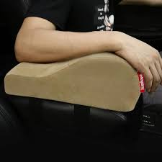

Handrest Foam

The mechanical properties required for handrest foam in car seats are crucial in ensuring comfort, durability, and ergonomic support. Here's a list of essential mechanical properties of handrest foam:

**Density**: The optimal density strikes a balance, providing adequate support without feeling too firm or too soft.

**Compression Resistance**: Handrest foam should be able to withstand compression forces from the user's hand without losing its shape or firmness over time.

**Elasticity:** The foam needs to retain its original shape after compression to maintain both comfort and support.

**Tensile Strength**: Resistance to tearing or breaking when stretched is vital for ensuring the foam's durability and longevity.

**Flexibility**: The foam should be flexible enough to conform to the shape of the hand while still providing sufficient support and comfort.

**Abrasion Resistance**: Resistance to wear and tear from repeated contact with hands ensures the foam's durability and longevity.

**Impact Absorption**: The capability to absorb impact forces from sudden movements or vibrations protects the hand and maintains comfort during use.

**Temperature Stability**: Stability across a range of temperatures, typically encountered in automotive environments, ensures consistent performance over time.

After extensive research, we have identified PU Foam as the most suitable material for the hand rest, capable of meeting all the required mechanical properties outlined earlier. However, instead of changing the material to reduce weight, we propose a design modification wherein 1/3rd of the thickness comprises hard PU foam and 2/3rd comprises soft PU foam. This design adjustment maintains similar resilience while reducing overall thickness and weight compared to using a complete layer of soft PU foam. Pugh's analysis of the new design indicates its potential as the optimal solution for weight reduction in handrest foam.

**Calculation of Mechanical Properties for Proposed Material Design (Handrest Foam):**

With the proposed combination of a one-third volume fraction of hard PU foam and a two-thirds volume fraction of soft PU foam,

**Effective Density =1/3*(Density of hard PU foam)+2/3*(Density of soft PU foam)**

Similarly, the values of each mechanical property for the new design can be calculated, taking into account the respective properties of both hard and soft PU foam components.

**Pugh Analysis:**

Justifications for the ratings we have allotted to the following criteria are listed below -

1. **Density** -
2. **Slider Assy -** The Density factor was assigned a rating of 3.5 for mild steel and 9 for Al SiC composites primarily due to density reduction. The overall reduction in the density achievable is a whooping 5000 kg/m3.
3. **Handrest Foam -** In this case, the Density factor is assigned a rating of 6 for PU Foam and 8 for the layered foam structure. This is because in comparison to the Slider Assay, a much lesser density reduction is achievable in this case. (Note that the density here refers to the effective density that takes into account the combined reduction of material density along with the reduction in thickness into one rating)
4. **Raw Materials Cost** -
5. **Slider Assy -** The raw material mild steel is much cheaper in comparison to the new material conceived. Hence the new material is given a rating of 5.5 and mild steel is given a rating of 8.5.
6. **Handrest Foam -** Again as mentioned in the case of Density, the materials cost is the effective cost. This factor is given a rating of 8 for old materials and 7.5 for new ones as the cost has only barely increased from Rs. 40/ft3 to Rs. 56/ft3.
7. **Ease of manufacturing** -
   1. **Slider Assy -** As raw materials are easily available and manufacturing techniques are well developed and commercially established, the ease of manufacturing is more for mild steel hence higher rating is given compared to composite where we require specific techniques and skilled labor for the process.
   2. **Handrest Foam -** Since we are proposing to change the design to a layered composition of foams, it is obvious that manufacturing this layered composition of foams will be difficult as we need to incorporate and join two different grades of foam together compared to single foam where no such extra activities are required.
8. **Manufacturing Cost** -
9. **Slider Assy -** As explained above, ease of manufacturing is more for mild steel the manufacturing cost will be lesser for the same.
10. **Handrest Foam -** As explained above, ease of manufacturing is more for old designs having a single layer of foam. The manufacturing cost will be less as compared to the new design where we are considering two layers since the act of joining two separate layers is higher in this case. Nevertheless, it will only be slightly higher as seen in the ratings table.
11. **Performance Quality (PQ) -**
    1. **Slider Assy:** proposed replacement has a much lower density, higher strength, high stiffness, low friction coefficient, high wear resistance, and high fatigue resistance compared to traditionally used Mild Steel. However, there’s an increase in the overall cost of production which is justified by the improvement in properties
    2. **Handrest Foam -** Since the handrest foam designed with the new material should give the same functionality in a lesser quantity of material consumed, the performance quality rating is higher than ordinary foam. Note that this rating too is only slightly higher than the previous material.

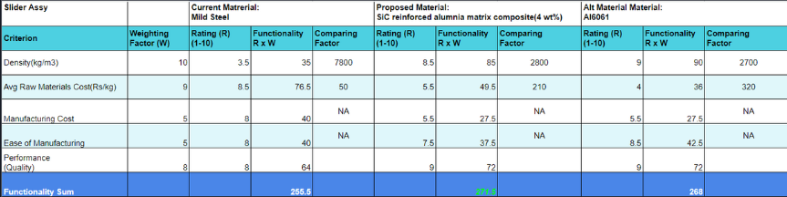

**Pugh Analysis of Slider Assembly**

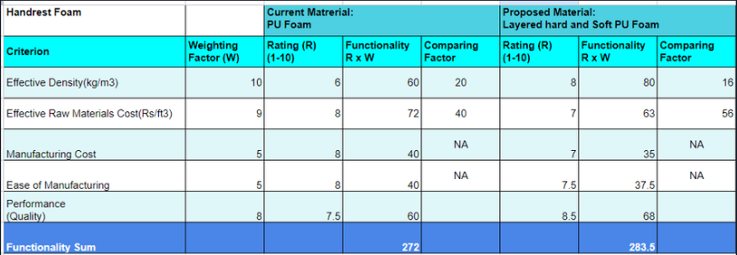

**Pugh Analysis of Handrest Foam**

**Results and Conclusions:**

* The Slider Assembly had an initial weight of 3.75 kg. After replacement, we propose that it will weigh 1.36 kg.
* Handrest foam weighs 0.526 kg and the proposed new foam will weigh 0.416 kg.
* The overall weight reduction per seat achieved is (3.75 + 0.526 - 1.36 - 0.416) = 2.5 kg. For 4 seats ~ **10kgs**.
* This amounts to an estimated overall carbon emission reduction of **12.5 g/km of CO2.**